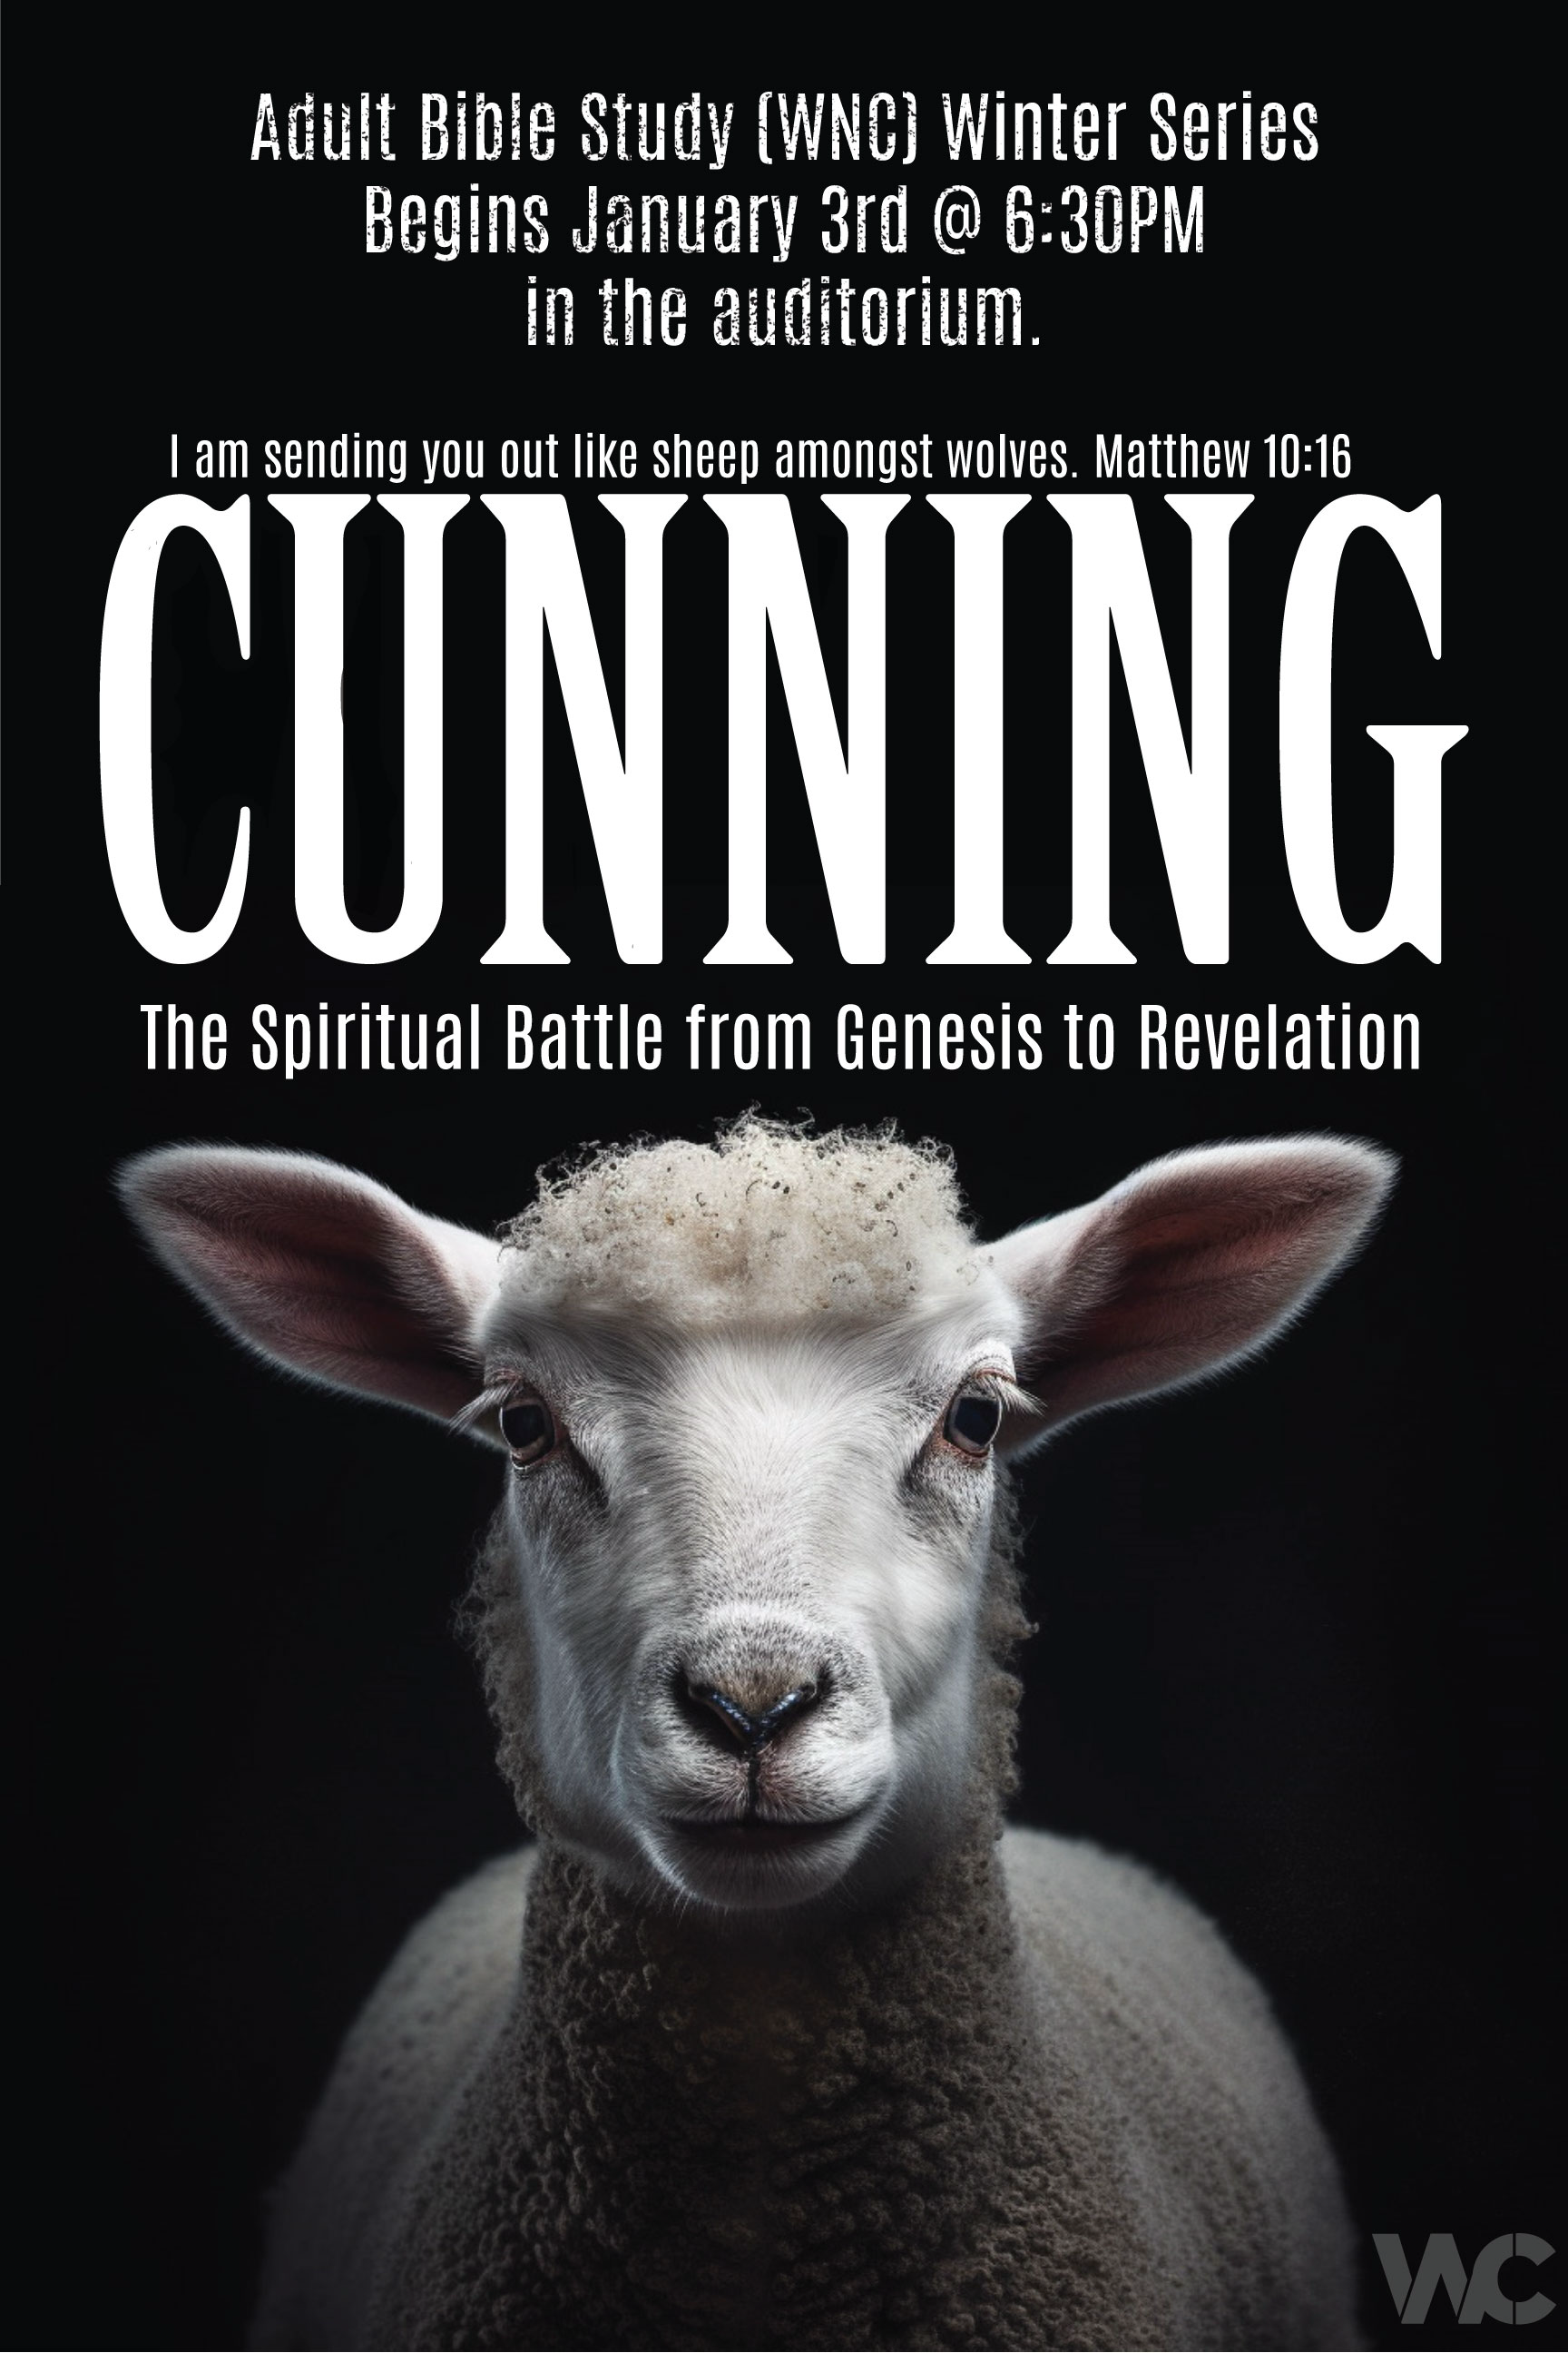

1/3rd In The Beginning
1/10th Foundations in the OT, Pt1
1/17th Prayer: Having the Conversation
1/24th
1/31st O just getting back
2/7th
2/14th O gone
2/21st
2/28th
3/6th O gone(have the boys)
3/13th
3/20th O gone
3/27th
(Easter is 3/31st)
- All Pr. O unless noted
- Chew On This Podcast-drops Thur pm/moving to our radio station WAJC 91.7/88.1 FM in February-Thursdays @8:30-9:30am

CUNNING
The Spiritual Battle from Genesis to Revelation
I am sending you out like sheep amongst wolves…Matthew 10:16a
Beginning with Jesus own statement: Intensity. Stark. Complete Awareness. CONFIDENCE
- I send you out, I do that.
- I know where I’m sending you.
- I know how complicated, entangled, warped, twisted, unrighteous it is.
- And I’m sending YOU.
- You will be re-presenting reality as I define it, not the smoke, mirrors, distortion that the enemy has seduced people to believe.
- Through the power of the Holy Spirit through you, I will be exerting My kingdom against the darkness that is claiming the lives I love.
- Sheep have no defense; I AM your defense.
- I choose the most unlikely, weak, defenseless and allow them to experience My strength. And what a strong defense I AM.
- Through your loving service and obedient expression of love to Me, even in the midst of fear, I will set people free from the enemy’s dominion to enjoy fellowship with the Father now & forever.

1 Peter 1: 10-12
¹⁰Of this salvation the prophets have inquired and searched carefully, who prophesied of the grace that would come to you, ¹¹searching what, or what manner of time, the Spirit of Christ who was in them was indicating when He testified beforehand the sufferings of Christ and the glories that would follow. ¹²To them it was revealed that, not to themselves, but to us they were ministering the things which now have been reported to you through those who have preached the gospel to you by the Holy Spirit sent from heaven—things which angels desire to look into.
[We get to here in the Church age.]

Our Definition of CUNNING:
The enemy: Having or showing skill in achieving one's ends by deceit or evasion.
We are to:
Having or showing skill in achieving one's ends by:
Knowledge. Wisdom. Shrewdness. Skill. Resourcefulness. Cleverness. Practice.
I am sending you out like sheep amongst wolves,
therefore, be wise as serpents and harmless as doves. Matthew 10:16
Our call to be shrewd, clever, wise--not with our own resources, but imbued by the Holy Spirit. [the Holy Spirit’s gifts of discernment, wisdom, knowledge, leadership-rightly applied]
Our secure framing in this series:
- We [Christians] are hidden with God in Christ-Jesus is sovereign over all of this. We need not be afraid to learn, in fact, it’s imperative we do. Jesus has this process.
- Repetition: We will be repeating concepts that may seem old hat to you-be grateful for the repetition and encouragement-Peter tells us it is beneficial. Remember there are those here who are hearing this for the first time. Let’s pray for all of us to get what the Holy Spirit would have us receive.
- Questions: rcb@realchurch.org or orleen@realchurch.org for questions related to what is shared.
- Safe: working to reveal the safety we have while sharing this material-this is a wackadoodle-free zone. [PO’s “don’t do this!”]. [Maranatha pillar-a balanced, Pentecostal message]

Assembling the puzzle:
We have learned: Recap
- Week 1: Highlight HO: God Created: His Rule, Angelic Beings (we have an enemy, he hates us, we are living in his world), His Children (Mankind)
- Week 2: Foundations in the OT, Pt 1
  - Highlight the HO
  - the Battleplan/mentioning mistakes they made.
  - Questions for ourselves-PERSONAL APPLICATION
    - Are we obeying what He has told us or do we require understanding in order to be obedient? [possibly insecurity or lack of trust leading us to rebellion?]
    - What are we listening to? Tolerating? Is anything “allowed” to shake our security in Jesus?
    - Does it cast doubt on the character of God or what He has told us?
Last Weeks’ ask: any testimonies of how he tried to enter your life this past week?

Before we begin:
Putting the puzzle together:
Edge pieces from last week: THIS IS HOW SECURE WE ARE
- Matthew 10:16 I am sending you out like sheep amongst wolves, therefore, be wise as serpents and harmless as doves.
An assignment from Jesus-therefore do-able.
- 1 John 4:4 You are of God, little children, and have overcome them, because He who is in you is greater than he who is in the world. [grammatically declarative, not interrogatory, present tense-is]
My dad is bigger than your dad.
- Galatians 4:4-7 4 But when the fullness of the time had come, God sent forth His Son, born of a woman, born under the law, 5 to redeem those who were under the law, that we might receive the adoption as sons.6 And because you are sons, God has sent forth [past tense-completed] the Spirit of His Son into your hearts, crying out, “Abba, Father!” 7 Therefore you are no longer a slave but a son, and if a son, then an heir of God through Christ. [grammatically declarative, past tense-completed, opinions do not alter this fact.]
Freed, empowered, inheritor-feelings are not a factor
- Colossians 2:15 Having disarmed principalities and powers, He made a public spectacle of them, triumphing over them in it. [speaking of Jesus, completed, past tense]
Authority has been reclaimed from the thief who through CUNNING swindled it and restored to its rightful place.
- 2 Chronicles 16:9 “For the eyes of the Lord range throughout the earth to strengthen those whose hearts are fully committed to him.”
- Our part-be fully committed to Him; His part-everything else. [this behavior continues-there is NO scripture to indicate He has stopped doing this, in fact, Matthew 28:20 tells us I will NEVER leave you, I will NEVER forsake you. Hebrews 13:5; Deut 31:6; Isaiah 41:10]

Introduce THIS WEEK: PRAYER: having the conversation

- Sequence of Power
- Prayer definition: Tim Chester
- 2 Corin 2:11 unpacked: Dutch Sheets
- Have the conversation: “Pray” Handout

Before we unpack PRAYER & how to live in the privilege of having the conversation, let’s understand what our current situation is.

1.Sequence of Power: Where are we & how did we get here? tracking power & authority HO [incomplete, a work in progress]
  - Understanding the difference between POWER and AUTHORITY:
Power
The Greek word dynamis is used of power, might, strength, ability, and sometimes of the one who exercises power. In the New Testament it is used of God who is described as ‘the Mighty One’ (Luke 1:49; see also Mark 12:24). It is used of Christ (Luke 24:19) whose miracles are literally ‘mighty acts’ (Luke 19:37). Dynamis is also used of the Holy Spirit (Luke 4:14; Acts 1:8), Christians (Eph. 1:19), the gospel (Rom. 1:16; 1 Cor. 1:18), and the coming of Christ (Matt. 24:30; Mark 9:1). The term dynastēs is used of a human official (Acts 8:27). In the Magnificat Mary sings of how God has brought down ‘rulers’ from their thrones (Luke 1:52). The New Testament also speaks of ‘the power of the enemy’ (Luke 10:19) who can do counterfeit ‘works of power’ (2 Thess. 2:9), while in Revelation 17:12–13 the ten kings give their power to the Beast. Romans 8:38–39; 1 Corinthians 15:24; Ephesians 1:21 and 1 Peter 3:22 also refer to ‘powers’, but whether these are human rulers or spiritual forces is disputed. Mark 13:25, however, speaks explicitly of ‘the powers in the heavens’ (esv; ‘the heavenly bodies’ in the niv).
The enemy has ABILITY. He is able.

Authority
The term exousia means authority or ruling power. In a similar way to dynamis, it is used both of authority and the bearer of authority. It is used for the authority of God, of Jesus and of believers, but also of secular authority or jurisdiction (Matt 8:9; Luke 12:11; 19:17; 20:20; 23:7; Titus 3:1). Its use in Romans 13:1–3 is generally held to refer to human authorities, although some have argued that this refers to angelic powers. Elsewhere exousia is clearly used of spiritual forces: ‘His intent was that now, through the church, the manifold wisdom of God should be made known to the rulers and authorities in the heavenly realms’ (Eph. 3:10).
Delegated authority. The RIGHT to do.
The enemy has power, he has NO RIGHT but acts anyway.
Matthew 28: 18 And Jesus came and spoke to them, saying, “All authority has been given to Me in heaven and on earth. 19 Go therefore and make disciples of all the nations, baptizing them in the name of the Father and of the Son and of the Holy Spirit, 20 teaching them to observe all things that I have commanded you; and lo, I am with you always, even to the end of the age.” Amen.

- Squatters: What Is a Squatter?
Tent in the front yard example
There are consequences to tolerating a squatter.
“Although people often use “squatter” to describe any unwanted person on their property, the term actually refers to a very specific scenario. In Minnesota, a squatter is someone who occupies an abandoned, foreclosed or unoccupied building or area without permission.
In very rare cases, a squatter may be able to legally remain on the property by claiming adverse possession. Adverse possession, which is sometimes called squatters rights, is the doctrine under which a squatter could acquire a property’s title without buying it. To claim squatters rights in Minnesota, a person must live on the property for at least 15 years and pay property taxes for five.”
https://www.atonyatlaw.com/tenant-squatting-issues/

- Prayer:
- Tim Chester quote from BST: Prayer
Prayer is the conversation of friends. It is not a mere convenience for letting God know what we are thinking or what we want. Prayer is that for which we were made. It is at the heart of God’s plan of salvation. To understand the tremendous privilege and import of prayer we need to see it in the context of God’s purpose to have a relationship with his people. ‘It is not possible for us to say, I will pray, or I will not pray, as if it were a question of pleasing ourselves; to be a Christian and to pray mean the same thing, and not a thing which can be left to our own wayward impulses. It is, rather, a necessity, as breathing is necessary to life.’ In other words, prayer is part of the definition of what it means to be a Christian. A Christian is someone who knows God through Jesus Christ, and to know God is to converse with him.

3. Dutch Sheets Quote: Intercessory Prayer:
2 Corinthians 2:11
“In order that no advantage be taken of us by Satan; for we are not ignorant of his schemes.”
The context of this verse is regarding FORGIVENESS, we do, however, see a principle revealed here.
- IGNORANT: The word “ignorant” is the Greek word agnoeo. It means “without knowledge or understanding of.” Our English word “agnostic” is derived from it. Technically, an agnostic is not a person who is unsure if he or she believes in God. We now use the word this way; but in actuality, an agnostic is a person who does not know or understand, regardless of the subject. We also get the word “ignore” from the same root. In this verse we’re urged not to ignore or be an agnostic—without understanding—where the devil is concerned.
- SCHEMES: “Schemes” is the word noema. It literally means “thought.” The verse is essentially saying, “Don’t be without understanding of the way Satan thinks.” Noema came to also mean “plans, schemes, plots, devices” because these things are born in the thoughts of the mind. for greater insight, let’s insert all of them into the verse: “Don’t be without understanding of the way your enemy thinks and operates—of his plans, plots, schemes and devices.” Is there not also a subtle promise here? If God suggests we are not to be ignorant of Satan’s schemes, He must be willing to reveal them to us.
- ADVANTAGE: What if we are unaware of his schemes? He’ll take “advantage” of us. The word is pleonekteo, which is a compound word meaning literally “to have or hold the greater portion” (pleon—“the greater part”; echo—“have or hold”). It is easy to see why this is a word for “covet.” It also means “overreach.”⁸
In boxing, the person who has the longer reach has the “advantage” and usually gets in more blows. The word is also translated “make a gain”; Satan makes a lot of gains on those who are unaware of his ways. Bullinger says it means “to make a prey of, to defraud.”
ALL TOGETHER:
Let’s put all these definitions together:
“To the degree we are ignorant of the way our adversary thinks and operates—of his plans, plots, schemes and devices—to that degree he will gain on us, prey on us, defraud us of what is ours and have or hold the greater portion.”
The greater portion of what? Whatever! Our homes, marriages, families, communities, money, government, nation, and more.

John 10:10-

4. Having the Conversation-“Pray” Handout

Prayer: An awareness for us before we jump into the rabbit hole.
I’ve observed over time, from my life & others’ lives, that exploring the topic of Prayer is an intriguing, engaging study. No end to the exploration. Loads of books, podcasts, videos, etc.
Be aware that a confused or occupied mind isn’t actually praying.
Studying about prayer isn’t praying.
We can be having a conversation with God while we do those things, but it is entirely too easy to be lost in the fascinating weeds and forget the point--prayer is talking with God. Getting close to Him, finding out His thoughts, His desires, sharing our own, carrying our situations and that of others to Him for His care. As with many things in our walk with God, it’s vital that we, the church, keep the main thing the main thing-staying connected & fully devoted to Him, being obedient to Him, anchored in the Word, solidly anchored in healthy Christian community, and sharing with anyone we can the hope they can have in Him.

Prayer is an honor. Responsibility. Obligation. Privilege.
Prayer is to the whole of our being like water is to the physical body.
We can certainly walk around dehydrated, but things don’t function properly when we do. It could lead to serious physical consequences.

- Perhaps the most prominent New Testament passage on spiritual warfare is Ephesians 6:10–20. Paul calls on the Ephesians to pray in the Spirit on all occasions with all kinds of prayers and requests (18). But this call to prayer is set in the context of a spiritual battle: our struggle is not against flesh and blood, but against the rulers, against the authorities, against the powers of this dark world and against the spiritual forces of evil in the heavenly realms (12).

Intercessory Prayer: Dutch Sheets
- In the light of this struggle we are to equip ourselves with the armour of God (13–17).
• We are in a very real war (see 2 Cor. 10:4; 1 Tim. 1:18).
• We are soldiers in this war (see Ps. 110:2–3; 2 Tim. 2:3–4).
• We are to wrestle against all levels of the kingdom of darkness (see Eph. 6:12).
• We are to resist the devil (which would in most situations be his demons) and he will flee from us (see Jas. 4:7; 1 Pet. 5:9).
• We are to tread on Satan and his demons (i.e., exercise authority over them—see Luke 10:19; Rom. 16:20).
• We are to cast out demons (see Mark 16:17).
• We have authority to bind (forbid) and loose (permit) when dealing with the agents and gates of hell (see Matt. 16:19).
• We have powerful weapons designed to overcome the kingdom of darkness (see 2 Cor. 10:4; Eph. 6:10–20).

Talk to God
Have the Conversation
Keep it simple.
You’ll be glad you did.
Your life & the lives of those you pray for will be impacted.

Tim Chester, The Message of Prayer: Approaching the Throne of Grace, ed. Derek Tidball, The Bible Speaks Today: Bible Themes Series (Nottingham, England: Inter-Varsity Press, 2003), 27.

